MSTeams notification for Bigquery long-running queries

To receive notifications on Teams for prolonged queries, various methods can be employed. However, in this instance, we will utilize Python to dispatch a notification message to MS Teams. To accomplish this, configuring a webhook at the channel level within the Teams is necessary. The subsequent steps outline the process for creating the required webhook.

1. In Microsoft Teams, go to the channel where you want to post messages.
2. Click on the ellipsis (three dots) next to the channel name and select “Connectors.”
3. Search for and select “Incoming Webhook.”
4. Click “Add” to add the incoming webhook to the channel.
5. Configure the webhook, provide a name, and upload an image if desired.
6. Copy the generated webhook URL.

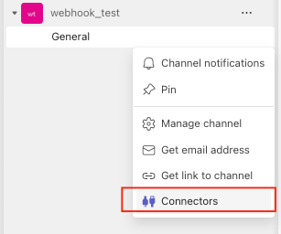
Once you get the Webhook URL copy the URL and put it on a placeholder. Now we have to write a big query to get the list of queries who is running from 5 minutes and taking 1500 slots.

Below is the BQ Query to get the list of queries running from 5 min and taking more than 1500 slots
Code is attached …

Now we will use the thing in the below Python program and schedule the program to run in 5 min.
you have to update the project_id and webhook URL and then once you run the Python code you will get the notification on the team's channel.
Python code -
Is attached ……

once you run the above code you will receive the notification on the team's group like the below-
